

**Spring 2015 CMPE 285**

Emergency HealthCare System  
***‘MediSwift’***

**PROJECT REPORT**

*Under the guidance of:*

**PROF. WEIDER YU**

*Submitted by:* ***Team #15***

ANUSHREE SONNI (009400534)

JASWANTH NUKALA (009394853)

SIDDHARTHA KADIYALA (008618402)

YESHWANTH RAVINDRA (009318400)

Table of Contents

Introduction 3

Objective: 3

Technologies used 4

Algorithm 4

Severity and Type of Health problem 4

Location of User 4

System Design Diagram: 5

Data Model: 6

Tabs of the application 7

Emergency Help Line Number: 7

Hospital Page: 7

Appointment Scheduler: 9

Conclusion: 9

References 10

# **INTRODUCTION**

The toll of health hazards has increased drastically and need for health emergency is the need of hour. Health hazards are not only concerned with the accidents, but also enwraps the issues related to other types of health hazards such as caused by environment, physical issues and so on. Hence keeping these situations in mind, we ‘Team 15 from CmpE 285’ have developed a project having, web application and mobile application, named “**MediSwift**”.

“**MediSwift**” provides help in the emergency health situations where the person can search for nearest hospital, search for ambulance and all the emergency services. Apart from emergency health services our application, both web and mobile, helps any person to book an appointment with the doctor, helps find some health tips. The application “**MediSwift**” thus addresses the issues related to health whether emergency health situation or some home remedies for health issues.

**OBJECTIVE**  
The objective of our health care emergency system “**MediSwift**” is to provide users, who are in health emergency, with an immediate and relevant help in the shortest available time.

In order to successfully achieve our goal, we have created different functionalities inside system and they can be availed by the user according to the health emergency requirement.

Following functions have been implemented in the system:

1. Search ambulance in shortest time.
2. Hospital emergency help line numbers.
3. Search for hospital on user location.
4. Book an appointment with doctor via email.
5. Get home remedy health advices for common health issues.
6. Get parking slots availability.
7. Login to the users.
8. Provide parking details when searched by hospital name.
9. Get parking slot availability for disabled.
10. Hospital/clinic service rating.
11. Hospital/medical center address, phone number, hours.
12. Names of medical and health services provided.
13. Location Access (e. g. distances, major intersections, directions, etc.).
14. Physician specialization fields.
15. Physician/hospital description.
16. Appointment service.

# **TECHNOLOGIES USED**

In making our web and mobile application “**MediSwift**”, the technologies we used are:

1. Microsoft Visual Studio: Visual studio is used in order to develop asp based Web application UI and backend code.
2. Android: Mobile application is created on android platform with Kitkat version.
3. SQL Server: Project’s database and tables are created on SQL server.
4. Microsoft SQL Azure: Project’s database hosts on Azure database in order to provide cloud access to both web and mobile application.
5. Google Maps: Google Maps provides location access to user in order to reach Hospital.
6. Google APIs: APIs has been used to read google map data in order to find shortest path connectivity.
7. Email system: Gmail API is used to draft email for user and send to the Hospital address.

# **ALGORITHM**

The algorithm and logic behind creating the “**MediSwift**” system depends on following two factors:

# **SEVERITY AND TYPE OF HEALTH PROBLEM**

User can have different kind of health emergency and should be served accordingly. It can be severe that require immediate treatment from hospital or it can be served with home treatment also. In order to achieve this, system should have different kind of options for user.

# **LOCATION OF USER**

In case of any type of health emergency, user should be provided with an immediate help. The location of user can be very remote or can be reachable from hospital/ambulance. In order to provide successful solution to user, system should provide location search for shortest path and or immediate help over the phone/website.

# **SYSTEM DESIGN DIAGRAM:**



Figure 1 System Diagram

The above is the system design used for our project “**MediSwift**”. It displays the different solutions our project provides when a patient is in Emergency situation. According to the severity of the condition, user can access our website or mobile app, for immediate help. The four solutions with severity level from High to low are:

1. User can enter a location and can search for available ambulances nearby to that location which will calculate the shortest path from the user location to the ambulance location.
2. Providing Helpline numbers on our website or mobile app of any hospital which is open 24x7.
3. User can search for any hospital and/ or location.
4. User can book an appointment with the specialist through email.
5. Health tips provided on our website and our mobile app.

# Data Model:

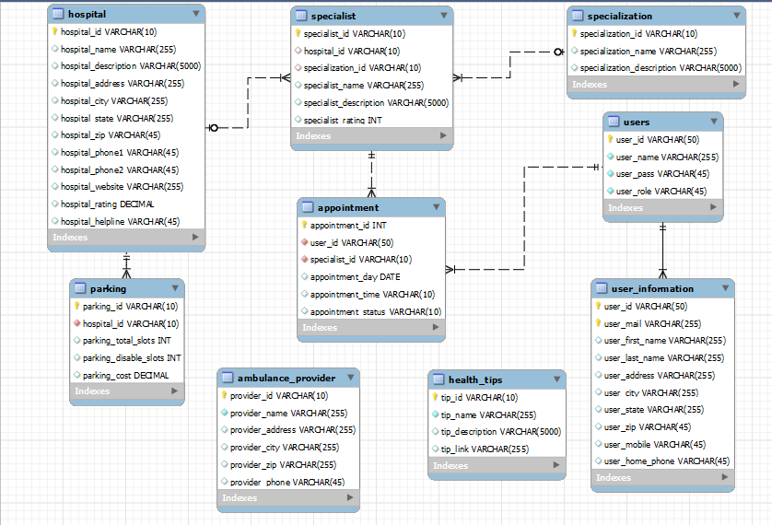

Figure 2 Data Model

# **FACILITIES IN THE APPLICATION:**

# **EMERGENCY HELP LINE NUMBER:**

* Upon selection of hospital, this functionality helps to connect with hospital in case of emergency which has low severity.
* For example, in case of light burns user can contact helpline number for advice to cure.

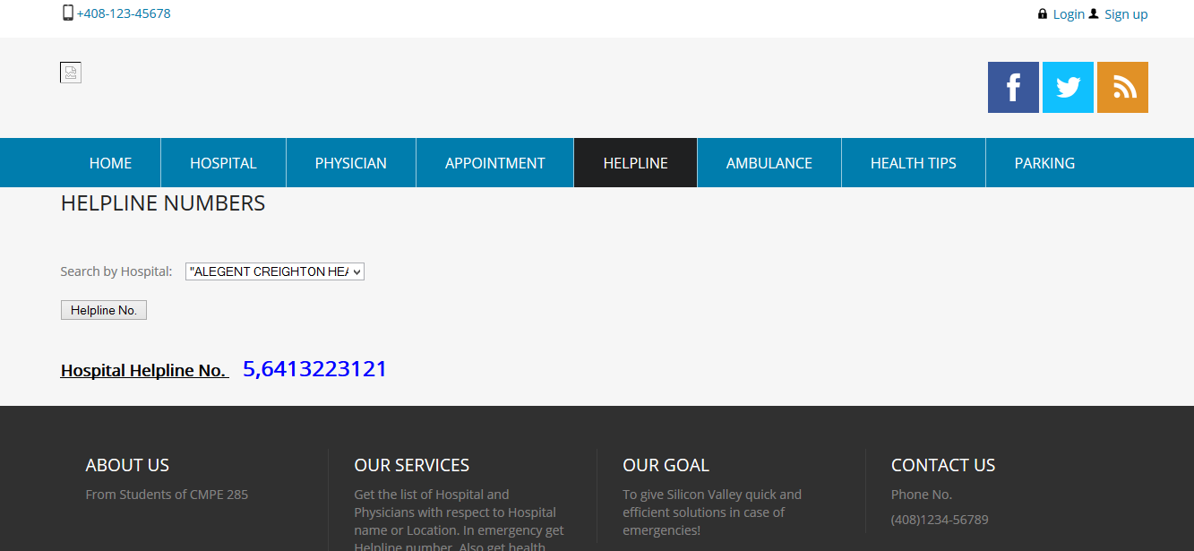

Figure 3 Emergency Help Line Page

# **HOSPITAL PAGE:**

* User can search for hospitals nearby by his specified nearest location or by searching for the desired hospital
* After selecting your search criteria, the user can get the Hospital details such as Description, Address, Phone numbers, website link and the Rating of the Hospital.
* The user can also get the Directions to the selected hospital by clicking on get Directions.
* For example, if the user is in Santa Clara and need’s medical help, so user can search for nearest hospital by entering the location Santa Clara or also by searching for the name of the hospital.

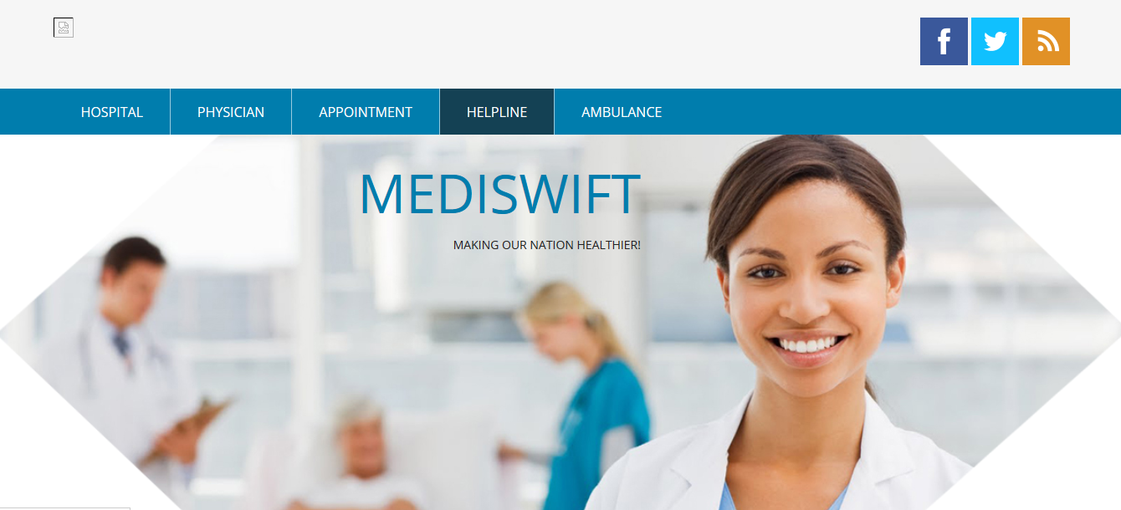

Figure 4 Hospital Page

# **APPOINTMENT SCHEDULER:**

* New user can sign up or the already registered users can make an appointment by clicking on the Appointment tab.
* To book an appointment, the user has to enter Physicians name, Date of Appointment, Patients email and contact number.
* User is acknowledged through email for the appointment.

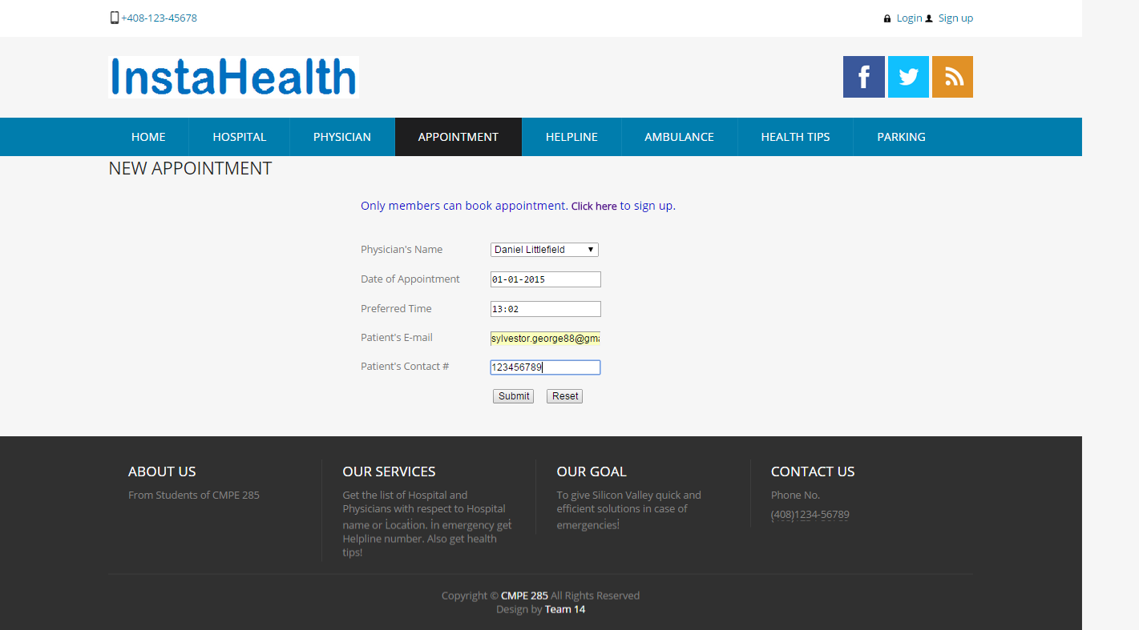

Figure 5 Appointment Page

**CONCLUSION**  
As depicted in our presentation of “**MediSwift**”, this application healthifies our nation. The application thus serves as a one stop medical application used for emergency as well as scheduling appointment, looking for hospital and the appropriate physician, getting the availability of parking slots, getting parking slots for disabled, searching ambulance, searching for doctor according to the specialization, viewing rating of hospital. All this are by just a click away. It’s a user friendly application developed for both web and mobile platforms.

# 

# **REFERENCES**

* <http://developer.android.com>
* <http://www.w3schools.com/asp/>
* <http://msdn.microsoft.com/en-us/default.aspx>
* <http://azure.microsoft.com/en-us/>
* <http://www.microsoft.com/en-us/server-cloud/products/sql-server/>